DIGITAL ASSIGNMENT - 1

TEAM MEMBERS:

1. 21BCE1950 - OMPRAKASH
2. 21BCE5828 - MOHAMED RIYAAS R

MACHINE LEARNING ALGORITHMS APPLIED:

1. Logistic Regression
2. K Nearest Classifer

TITLE OF THE PROJECT:

1. Cardiovascular Risk Assessment
2. Heart Health Prognosis

DATASETS TAKEN:

<https://thecleverprogrammer.com/wp-content/uploads/2020/05/heart.csv>

PERFORMANCE METRICS:

Logistic Regression

Test Result

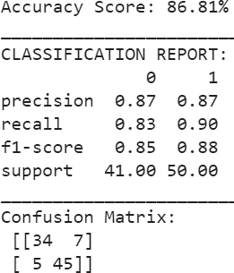

AUC-ROC (“Area Under the Curve” of the “Receiver Operating Characteristic” curve.)

0.9165853658536586

PERFORMANCE METRICS:

Logistic Regression

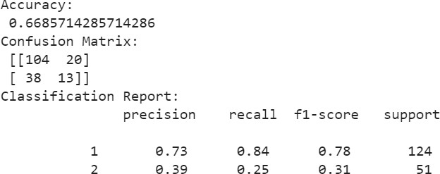

CONTRIBUTION TABLE:

|  |  |  |  |
| --- | --- | --- | --- |
| **Team Member** | **Project Taken** | **Algorithm Used** | **Contribution** |
| 21BCE1950  Omprakash | Heart Health Prognosis | K Nearest Classifier | Executed K Nearest algorithm, calculated cross validation score and visualization and exploration  of data. |
| 21BCE5828  Mohamed Riyaas | Cardiovascular Risk Assessment | Logistic Regression | Executed Logistic Regression algorithm, calculated cross validation score and added AUC- ROC Performance  Metrics. |

**LINK FOR THE GOOGLE COLAB FILE:**

[**https://colab.research.google.com/drive/1ai_VFvVp9VGfrWT_aGINMnvGIttRdLYo?usp=sh**](https://colab.research.google.com/drive/1ai_VFvVp9VGfrWT_aGINMnvGIttRdLYo?usp=sharing)[**aring**](https://colab.research.google.com/drive/1ai_VFvVp9VGfrWT_aGINMnvGIttRdLYo?usp=sharing)

**LINK FOR THE IEEE CONFERENCE TO SUBMIT :**

[**https://icoiss.com/committee.html**](https://icoiss.com/committee.html)

**DEADLINE FOR SUBMISSION:**

26th January 2024